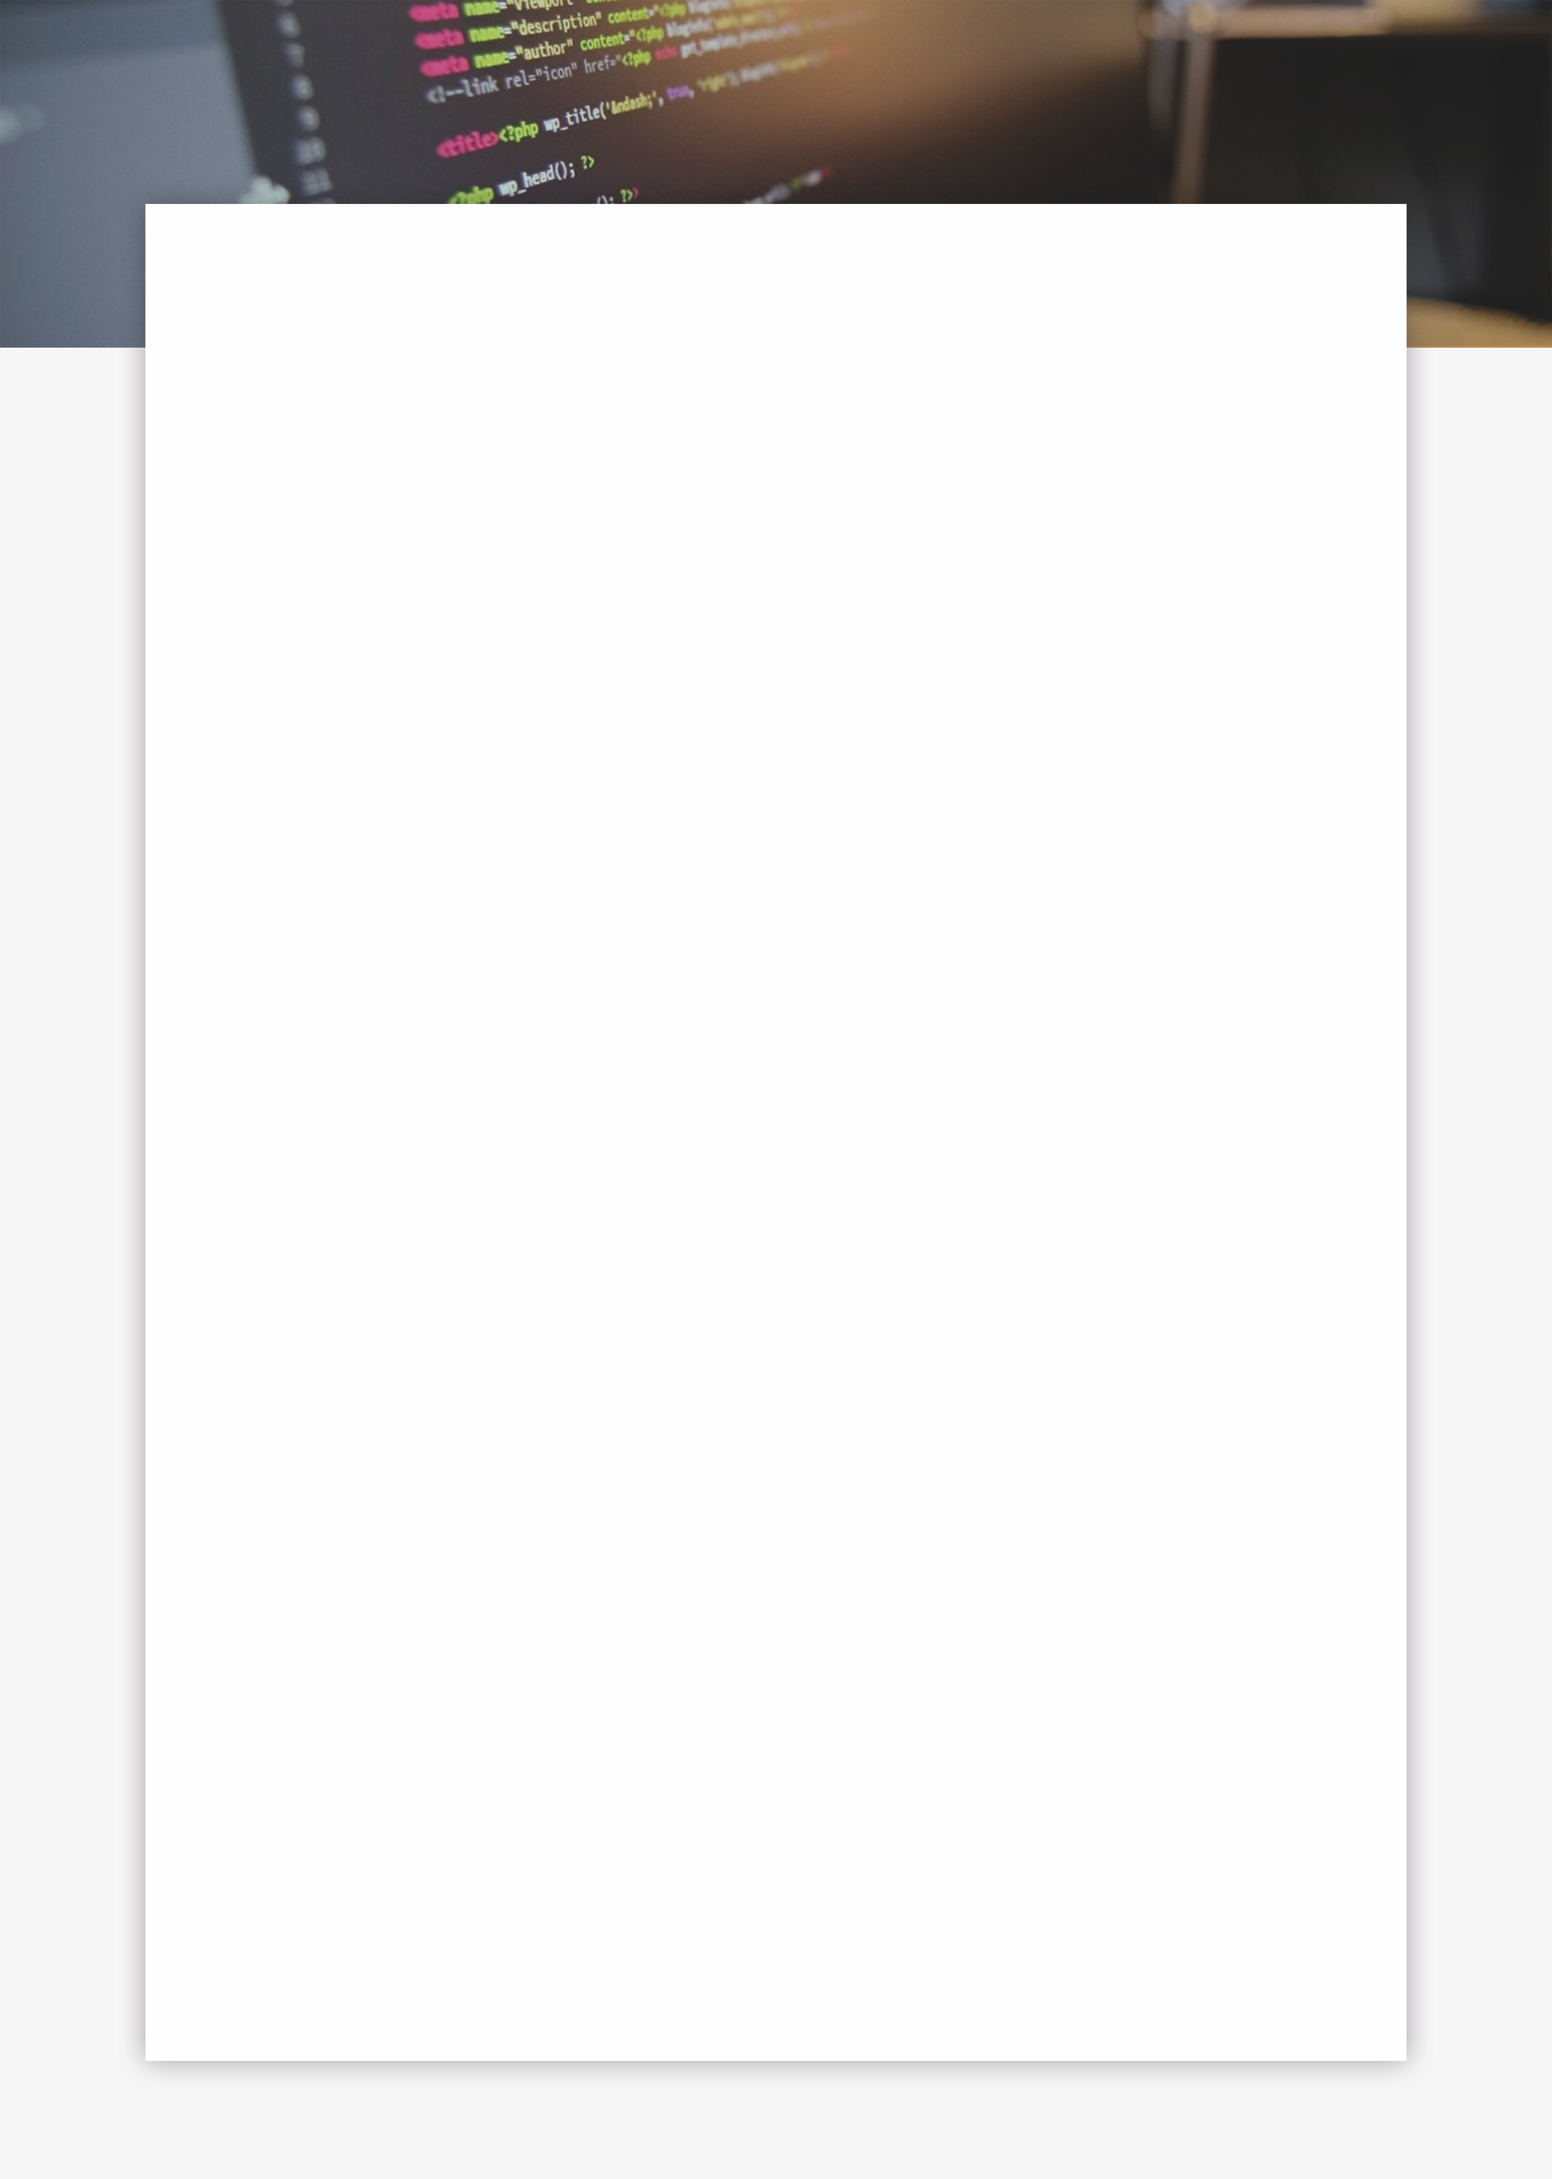



 Education

**Kansas State University** **/ Bachelors in Computer Engineering**August 2017 / May 2021  
Member of the Powercat Motorsports Formula SAE team, Electrical Systems Team; Hack K-State Club; Game Development Club; KSU IEEE Club; Cyber Defence Club and KSU IMBS.

**Shawnee Mission East** **/ High school Diploma**August 2013 / May 2017

Member of various sports teams, Automotive Technologies Club, Journalism, and Robotics Club.

 Work Experience

**Collegian Media Group** **/ Web Developer | Head of Technology**October 2017 / Present  
Web Developer for the student publications department at Kansas State University. Created and developed websites for each of the publications, and multiple colleges and companies around campus.

**HitchPin LLC.** **/ Software Engineer | Head of UI/UX design**January 2018 / Present  
Worked on developing and creating an app for a Manhattan based start-up. Lead multiple projects on creating and developing a responsive and fresh UI design that would simple for the user. Also lead the creation of secure mobile payments.

**Freelance Web Developer** October 2016 / Present  
Worked as freelance Web Developer to help my parents make ends meet. Created and redesigned multiple websites for teachers, friends, and colleagues throughout high school.

**IEEE/ Web Developer | KSU Student Chapter**January 2018 / Present  
Created and developing a website for the Kansas State University chapter of the International order of Electrical and Electronics Engineer Society. The website is used as a focal point to draw in new members into the society.

 Get in Touch

  
 **+ 1** (913) **486 9114**

  
**amasson99**@gmail.com

  
  
www.alexanderjmasson.com

github.com/amasson99

linkedin.com/alex-massonb21574141

 Skills

Html  
  
CSS  
  
JavaScript  
  
Java  
  
C

Command Line

Security

 Profile

My name is Alex Masson, and I am a professional Web Developer and Software Engineer. I am also a student at Kansas State University pursuing a degree in Computer Engineering.

**ALEX MASSON**Web Developer / Software Engineer